10. LINKED LIST OPERATIONS

**Aim**

To write a C program to perform **Linked List operations** such as **Insertion, Deletion, and Traversal**.

**Algorithm**

1. **Start**
2. Create a structure Node with data and next pointer.
3. Initialize head = NULL.
4. **Insertion**:
   * Create a new node.
   * If list is empty, make head = newNode.
   * Else insert at end (or specific position).
5. **Deletion**:
   * If list is empty → print "List empty".
   * Else traverse and remove the required node.
6. **Traversal**:
   * Start from head.
   * Print each node until NULL.
7. Repeat operations until user exits.
8. **Stop**.

**PROGRAM**

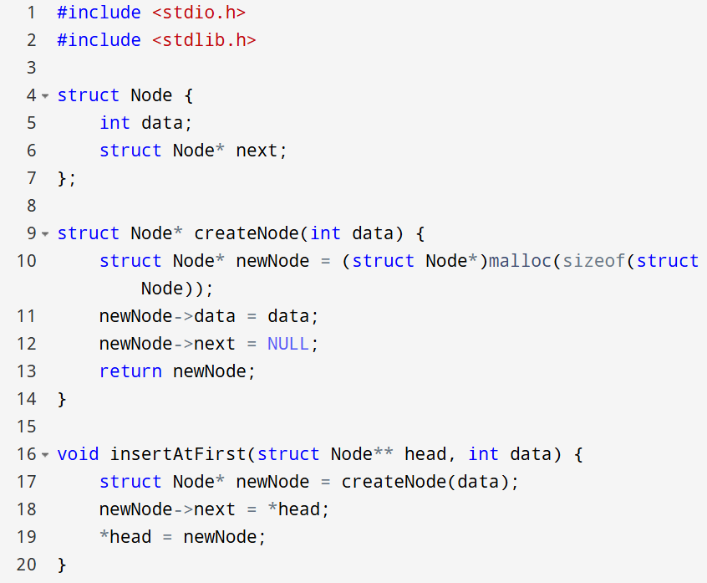

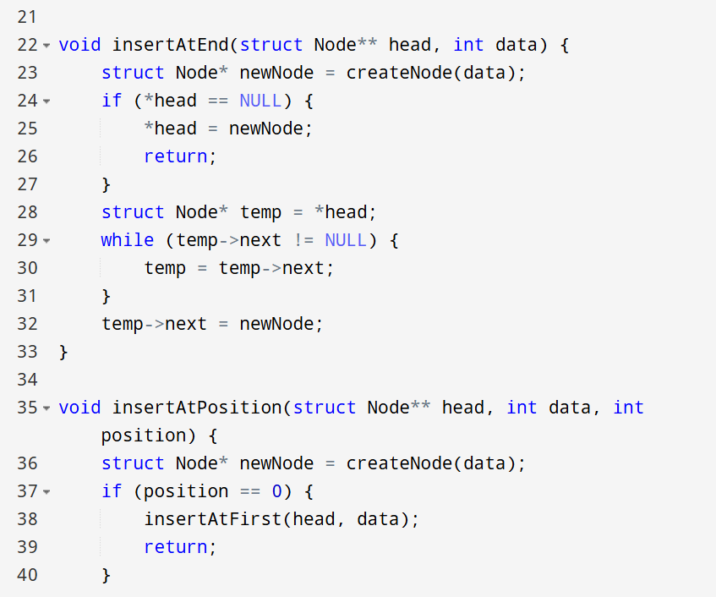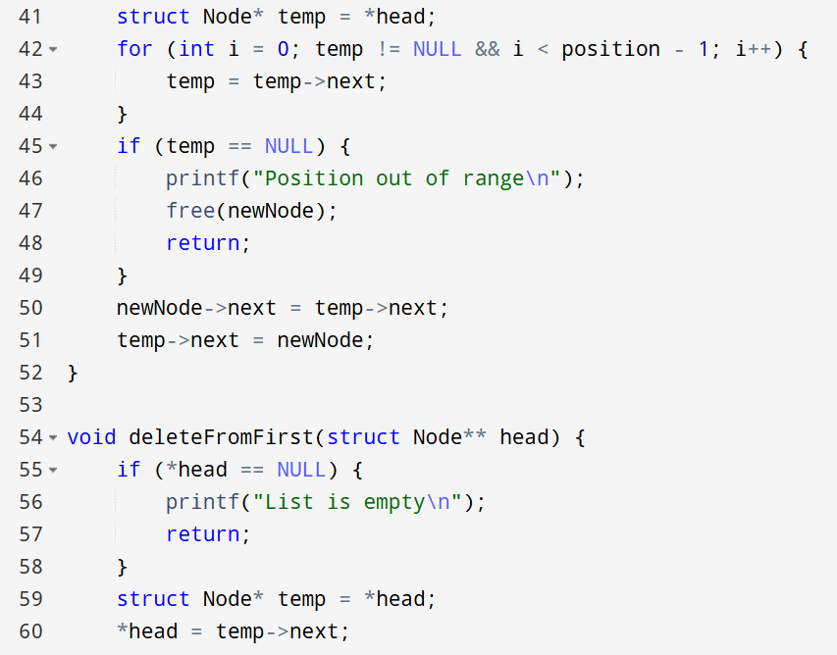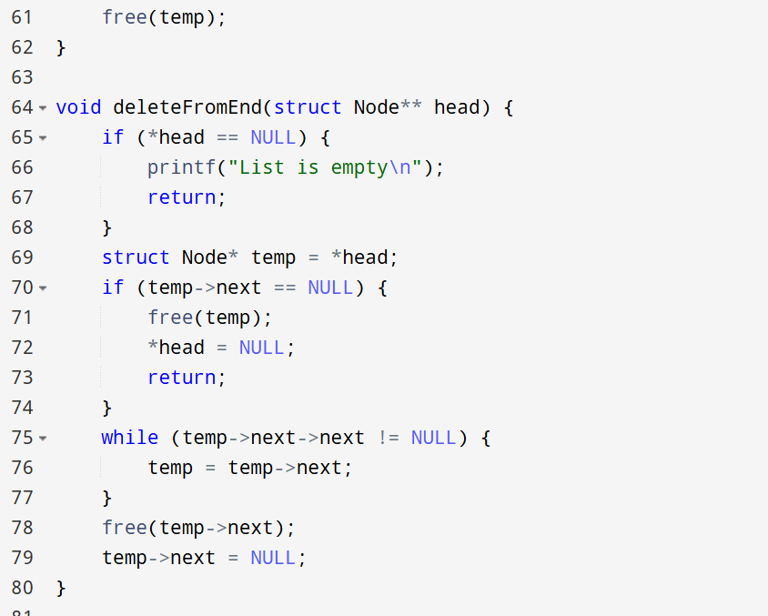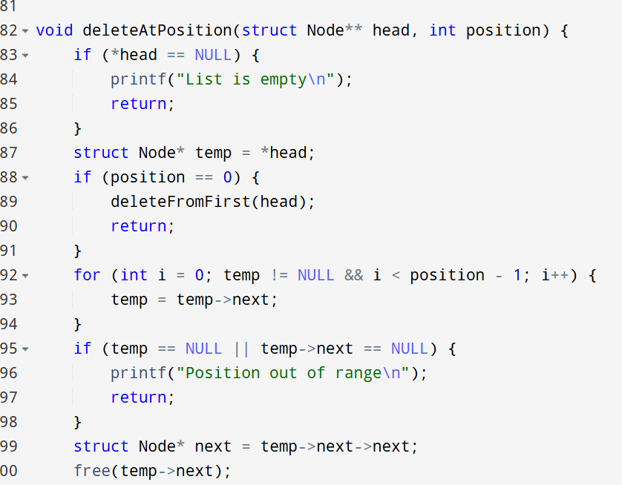

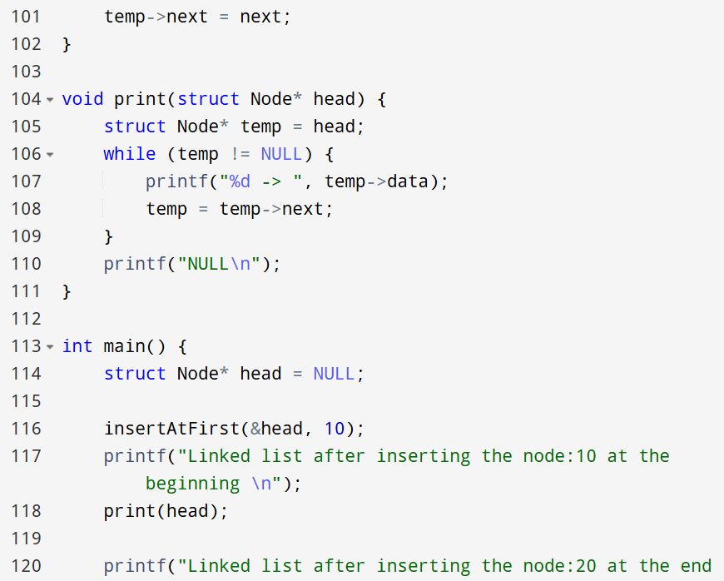

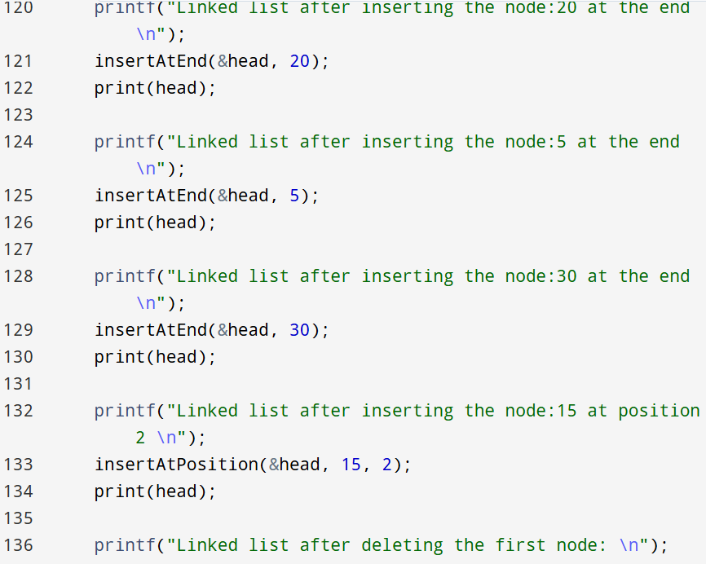

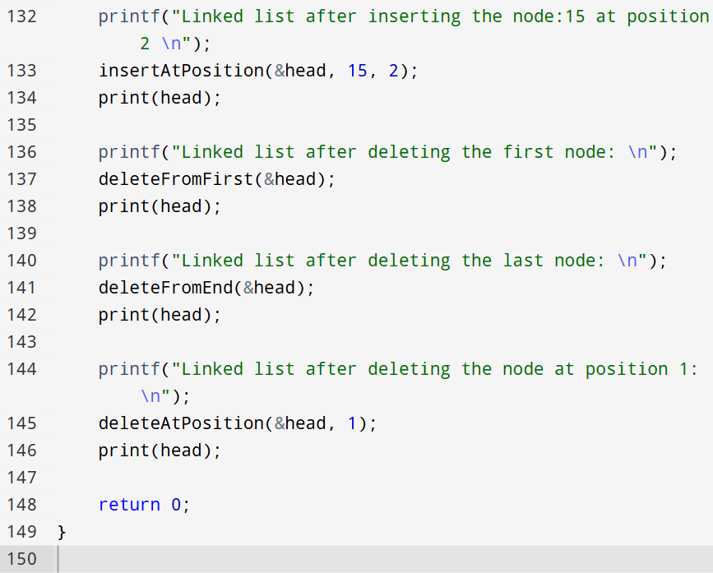

OUTPUT

